K L UNIVERSITY
FRESHMAN ENGINEERING DEPARTMENT

A Project Based Lab Report On
QUIZ ASSESSMENT & PERFORMANCE ANALYTICS SYSTEM(QAPAS)

SUBMITTED BY:
ID NUMBER NAME
2500031815-T.SANTHOSH

UNDER THE ESTEEMED GUIDANCE OF

Mr. Repudi Pitchiah Asst.Prof



KL UNIVERSITY
Green fields, Vaddeswaram – 522 502 Guntur Dt., AP, India.

DEPARTMENT OF BASIC ENGINEERING SCIENCES



CERTIFICATE

This is to certify that the project based laboratory report entitled “QUIZ ASSESSMENT & PERFORMANCE ANALYTICS SYSTEM(QAPAS)” submitted by T.SANTHOSH bearing Regd. No. 2500031815 to the DEPARTMENT of BASIC ENGINEERING SICENCE-I, K L UNIVERSITY in partial fulfillment of the requirements for the completion of a project based Laboratory in “PYTHON PROGRAMMING” course in I B Tech II Semester, is a Bonafede record of the work carried out by him/her under my supervision during the academic year 2025 – 2026.

PROJECT SUPERVISOR HEAD OF THE DEPARTMENT Mr. Repudi Pitchiah Dr. D. HARITHA

ACKNOWLEDGEMENTS

It is great pleasure for me to express my gratitude to our honorable President.

Sri. Koneru Satyanarayana, for giving the opportunity and platform with facilities in accomplishing the project-based laboratory report.
I express sincere gratitude to our Director Dr. A. Jagdeesh for his administration towards our academic growth.
I express sincere gratitude to our Coordinator and HOD-BES Dr. D. Haritha for her leadership and constant motivation provided in successful completion of our academic semester. I record it as my privilege to deeply thank you for providing us with the efficient faculty and facilities to make our ideas into reality.
I express my sincere thanks to our project supervisor MR. Repudi Pitchiah for his novel association of ideas, encouragement, appreciation, and intellectual zeal which motivated us to venture this project successfully.
Finally, we are pleased to acknowledge our indebtedness to all those who devoted themselves directly or indirectly to making this project a success.

T.SANTHOSH-2500031815

ABSTRACT

The Quiz Assessment & Performance Analytics System (QAPAS) is a web-based application developed to streamline the process of conducting quizzes and evaluating student performance. The system enables educators to create and manage quizzes, while students can attempt them in an interactive and user-friendly environment.

QAPAS automates answer evaluation and provides instant results, reducing manual effort and minimizing errors. In addition to scoring, the system offers detailed performance analytics, including accuracy, topic-wise analysis, and progress tracking. These insights help educators identify learning gaps and improve teaching strategies.

The platform supports secure login and role-based access for administrators, teachers, and students, ensuring efficient data management. Overall, QAPAS enhances the assessment process by making it faster, reliable, and data-driven, contributing to improved educational outcomes

The system incorporates data visualization techniques such as charts and graphs to present performance analysis in a clear and understandable manner.

It is designed to be scalable and adaptable, allowing integration with modern learning platforms and supporting a large number of users efficiently.

INDEX

S.NO | TITLE | PAGE NO
1 | Introduction
2 | Aim of the Project
2.1 | Advantages & Disadvantages
2.2 | Future Implementation
3 | Software & Hardware Details
4 | Data Flow Diagram
5 | Algorithm for each module
6 | Implementation
7 | Integration and System Testing
8 | Conclusion

INTRODUCTION

In the modern era, technology has become an integral part of the education system, transforming traditional teaching and learning methods into more interactive and efficient processes. Educational institutions are increasingly adopting digital platforms to enhance learning experiences and streamline academic activities. One such advancement is the use of online quiz systems for assessment and evaluation.
Traditional examination methods often involve manual processes such as paper-based tests, answer evaluation, and result compilation. These methods are time-consuming, prone to human errors, and lack immediate feedback for students. Additionally, they do not provide detailed insights into student performance, making it difficult for educators to identify areas where students need improvement.
To address these challenges, the Quiz Assessment & Performance Analytics System (QAPAS) is developed as a comprehensive solution for conducting quizzes and analyzing student performance. This system automates the entire assessment process, from quiz creation to result generation, thereby reducing manual effort and improving accuracy.
QAPAS provides a user-friendly interface that allows teachers to create and manage quizzes easily. They can add multiple-choice questions, set time limits, and customize quizzes according to their requirements. Students can access the system, attempt quizzes, and receive instant feedback on their performance.
A key feature of the system is its ability to perform detailed performance analysis. It evaluates not only the total score but also provides insights into accuracy, topic-wise performance, and overall progress. This helps educators understand the strengths and weaknesses of students and take appropriate measures to improve their learning outcomes.
The system also supports role-based access, ensuring that administrators, teachers, and students have appropriate permissions. This enhances security and ensures proper management of data within the system
Furthermore, QAPAS includes reporting and visualization features that present performance data in the form of charts and graphs. These visual representations make it easier to interpret results and track progress over time.
The implementation of such a system significantly reduces the workload of educators by automating repetitive tasks such as evaluation and report generation. It also benefits students by providing quick results and constructive feedback, which helps them improve their performance.
Another important aspect of QAPAS is its scalability. The system can handle a large number of users simultaneously, making it suitable for schools, colleges, and online learning platforms.
In addition, the system can be integrated with other educational tools and platforms, enhancing its functionality and usability. This makes it a flexible solution that can adapt to different educational environments.

.

AIM
The primary aim of the Quiz Assessment & Performance Analytics System (QAPAS) is to design and develop an efficient, reliable, and user-friendly platform for conducting online quizzes and analyzing student performance in a systematic manner.

The system aims to replace traditional examination methods with a digital solution that reduces manual effort and improves accuracy in evaluation. It focuses on automating the entire assessment process, starting from quiz creation to result generation
.
Another important aim is to provide an easy-to-use interface for educators to create, manage, and update quizzes according to their academic requirements. The system allows teachers to design multiple-choice questions, set time limits, and control the overall structure of the quiz
.
QAPAS also aims to offer a seamless experience for students by enabling them to attempt quizzes online and receive instant feedback on their performance. This helps students understand their mistakes and improve their learning process.

A key objective of the system is to analyze student performance in detail. It not only calculates scores but also evaluates accuracy, topic-wise performance, and overall progress. This helps in identifying strengths and weaknesses of students.

The system aims to support data-driven decision-making by providing meaningful insights through performance analytics. These insights assist educators in improving teaching strategies and enhancing student outcomes.

Another aim is to generate detailed reports that present student performance in a clear and understandable format. These reports help both teachers and students track progress over time.

QAPAS also focuses on ensuring data security and privacy by implementing authentication and role-based access control. This ensures that only authorized users can access the system.

The system aims to be scalable so that it can handle a large number of users simultaneously without affecting performance. This makes it suitable for schools, colleges, and online learning platforms.

It also aims to be flexible and adaptable, allowing integration with other educational systems and tools. This enhances its usability and functionality in different environments.

Another objective is to reduce errors in evaluation by eliminating manual checking and ensuring accurate and consistent results.

The system aims to save time for educators by automating repetitive tasks such as grading and report generation.

ADVANTAGES
Saves Time: Automates quiz evaluation and result generation, reducing manual work for teachers.

High Accuracy: Eliminates human errors in checking answers and calculating scores.

Instant Results: Students receive immediate feedback after completing quizzes.

Performance Analytics: Provides detailed analysis such as accuracy, strengths, and weak areas.

User-Friendly Interface: Easy to use for both teachers and students.

Data Visualization: Displays results using charts and graphs for better understanding.

Scalability: Can handle a large number of users simultaneously.

Secure System: Ensures data safety through login authentication and role-based access.

Improves Learning: Helps students identify mistakes and improve performance.

Reduces Paper Usage: Promotes an eco-friendly digital assessment process.

Efficient Management: Simplifies quiz creation, modification, and storage.

Accessibility: Can be accessed anytime and anywhere through the internet.

DISADVANTAGES
Internet Dependency: Requires a stable internet connection to access and attempt quizzes.

Limited Question Types: Basic systems may support mainly objective questions (MCQs) and not descriptive answers.

Technical Issues: System crashes, bugs, or server downtime can affect performance.

Initial Development Cost: Requires time, effort, and resources to design and implement the system.

Security Risks: Possibility of data breaches or unauthorized access if security is weak.

Device Requirement: Users must have access to a computer or smartphone.

Reduced Human Interaction: Less face-to-face communication between teachers and students.

FUTURE IMPLEMENTATION
The Quiz Assessment & Performance Analytics System (QAPAS) can be further enhanced by integrating advanced technologies and additional features to improve its efficiency and usability. In future, artificial intelligence can be incorporated to analyze student performance, predict outcomes, and provide personalized learning recommendations. This will help in creating a more intelligent and adaptive system.

Another important improvement is the development of an adaptive learning mechanism, where the difficulty level of quizzes changes automatically based on the student’s performance. This ensures that each student receives a customized learning experience according to their knowledge level

The system can also be extended to support subjective or descriptive answers by implementing automated or semi-automated evaluation techniques. This will make the system more versatile and suitable for a wider range of subjects.

Developing a mobile application for Android and iOS platforms is another future enhancement, which will improve accessibility and allow users to take quizzes anytime and anywhere. In addition, deploying the system on cloud platforms will increase scalability, storage capacity, and overall system performance.
The system can also be improved by integrating advanced data visualization tools such as interactive dashboards, which provide deeper insights into performance metrics. These dashboards can help educators make informed decisions by analyzing trends, comparisons, and progress over time.
Another future enhancement is the integration of QAPAS with existing Learning Management Systems (LMS), enabling seamless data sharing and better management of academic activities. Adding multi-language support will make the system more inclusive and accessible to users from different regions and backgrounds.

Security features can be further strengthened by implementing real-time monitoring and online proctoring techniques such as webcam-based supervision to minimize cheating during examinations. Advanced data visualization tools can also be added to present performance analysis in a more interactive and understandable format.

Overall, these future enhancements will transform QAPAS into a more powerful, scalable, and intelligent system, making it highly effective for modern digital education environments.

Gamification is another promising feature that can be implemented to increase student motivation and engagement. Elements such as points, badges, leaderboards, and rewards can make the learning process more interactive and enjoyable.

In addition, the system can include features like automated feedback generation, recommendation systems for study materials, and performance benchmarking against peers. These features will further enhance the learning experience and help students achieve better results.

Finally, continuous updates and improvements based on user feedback and technological advancements will ensure that QAPAS remains relevant, efficient, and competitive in the evolving field of digital education.

SYSTEM REQUIREMENTS

SOFTWARE REQUIREMENTS:
The major software requirements of the project are as follows: Language: Turbo-C.
Operating system: Windows 10 or more.
Technical requirements: Monitor, CPU, Keyboard, Mouse, etc...

HARDWARE REQUIREMENTS:
The hardware requirements that map towards the software are as follows: RAM: 8 GB.
Processor: i5/i7.

DATA FLOW DIAGRAM
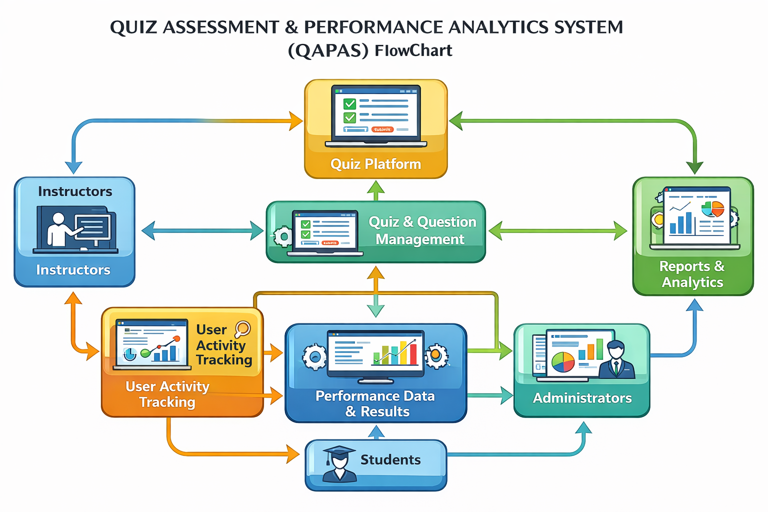

IMPLEMENTATION

# QAPAS - Quiz Assessment & Performance Analytics System

class QuizSystem:
def __init__(self):
self.questions = []
self.scores = {}

# Add questions
def add_question(self, question, options, answer):
self.questions.append({
"question": question,
"options": options,
"answer": answer
})

# Conduct quiz
def conduct_quiz(self, student_name):
print(f"\nWelcome {student_name} to QAPAS Quiz\n")
score = 0

for i, q in enumerate(self.questions, start=1):
print(f"\nQ{i}: {q['question']}")
for idx, option in enumerate(q['options'], start=1):
print(f"{idx}. {option}")

try:
user_ans = int(input("Enter your answer (1-4): "))
if q['options'][user_ans - 1].lower() == q['answer'].lower():
score += 1
except:
print("Invalid input!")

self.scores[student_name] = score
print(f"\nYour Score: {score}/{len(self.questions)}")

# Performance analytics
def show_analytics(self):
print("\n--- Performance Analytics ---")
if not self.scores:
print("No data available.
return

total_students = len(self.scores)
total_score = sum(self.scores.values())
avg_score = total_score / total_students

print(f"Total Students: {total_students}")
print(f"Average Score: {avg_score:.2f}")

print("\nIndividual Scores:")
for student, score in self.scores.items():
print(f"{student}: {score}")

# Main program
quiz = QuizSystem()

# Add sample questions
quiz.add_question(
"What is the capital of India?",
["Mumbai", "Delhi", "Chennai", "Kolkata"],
"Delhi"
)

quiz.add_question(
"Which language is used for web development?",
["Python", "HTML", "C", "Java"],
"HTML"
)

quiz.add_question(
"2 + 2 = ?",
["3", "4", "5", "6"],
"4"
)

# Run system
while True:
print("\n--- QAPAS MENU ---")
print("1. Take Quiz")
print("2. View Analytics")
print("3. Exit")
choice = input("Enter choice: ")

if choice == '1':
name = input("Enter your name: ")
quiz.conduct_quiz(name)

elif choice == '2':
quiz.show_analytics()

elif choice == '3':
print("Exiting QAPAS...")
break

else:
print("Invalid choice!")

CONCLUSION

The Quiz Assessment & Performance Analytics System (QAPAS) successfully provides an efficient and automated solution for conducting quizzes and evaluating student performance. The system reduces the limitations of traditional assessment methods by minimizing manual effort, improving accuracy, and delivering instant results.

Through its quiz management and automatic evaluation features, QAPAS simplifies the process for educators while offering a smooth and interactive experience for students. The inclusion of performance analytics helps in identifying strengths and weaknesses, enabling better understanding of student progress and supporting data-driven decision-making.

The system also ensures organized data management and secure access through role-based functionality. Its ability to generate reports and visualize performance makes the evaluation process more transparent and effective.

Overall, QAPAS enhances the quality of education by integrating technology with assessment. It saves time, improves efficiency, and supports continuous learning. With further enhancements, the system can evolve into a more advanced and intelligent platform suitable for modern digital education environment

QAPAS provides an efficient and accurate system for conducting quizzes and analyzing student performance.

It enhances learning outcomes by offering instant feedback and detailed performance insights.

